# Python Radio 41: Radar!

[Simon Quellen Field](https://medium.com/@simon.field_37276?source=post_page---byline--49a4dccc82d7---------------------------------------)

[Simon Quellen Field](https://medium.com/@simon.field_37276?source=post_page---byline--49a4dccc82d7---------------------------------------)

Follow

5 min read

·

May 30, 2025

Listen

Share

More

Exploring microwave signals above 3 GHz.

Press enter or click to view image in full size

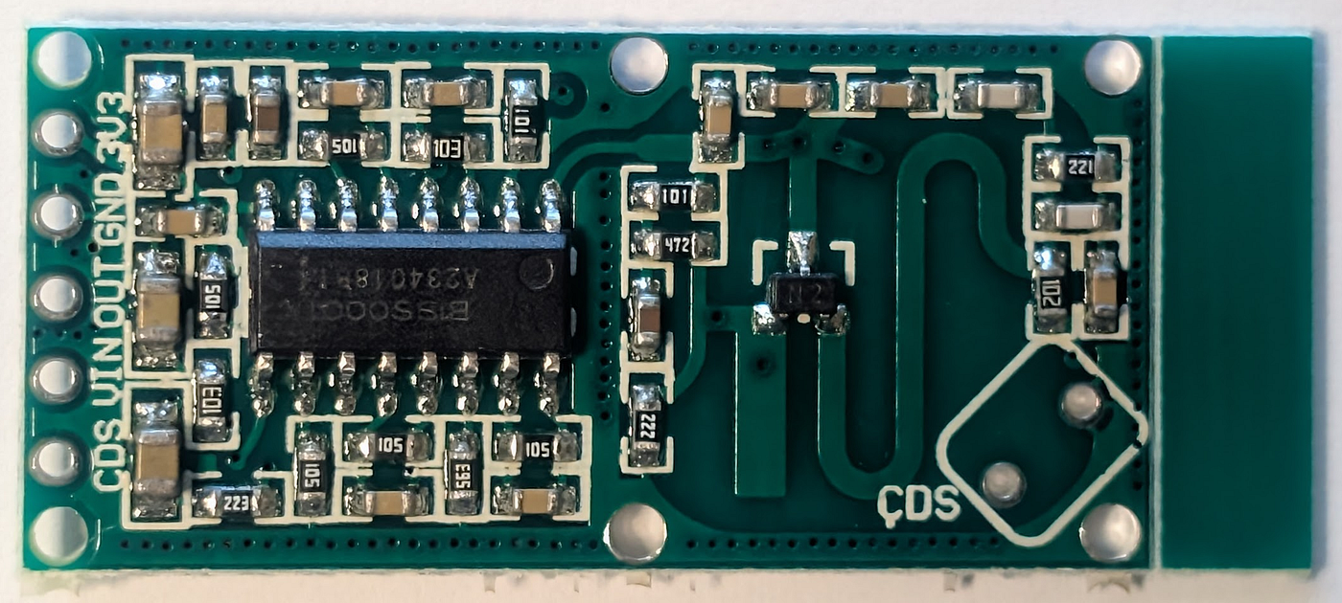

All images by the author.

You can buy microwave motion detectors for less than a dollar. I bought a 10-pack on Amazon for $7.99.

Sometimes advertised as “Doppler radar” devices, the RCWL-0516 is a little board that puts out a 3.16 GHz continuous wave and listens for reflections.

They don’t operate the same way that aircraft radars or weather radars do. Those send out pulses and time the reflections to get the range and detect wavelength changes to get the speed towards or away (using the Doppler effect).

Despite the advertising, these little boards detect the changes in the phase of the reflected waves by heterodyning them (“beating”) with the continuous-wave transmissions. The interference of the forward and reflected waves cause changes in the output amplitude that are in the audio range or lower.

Press enter or click to view image in full size

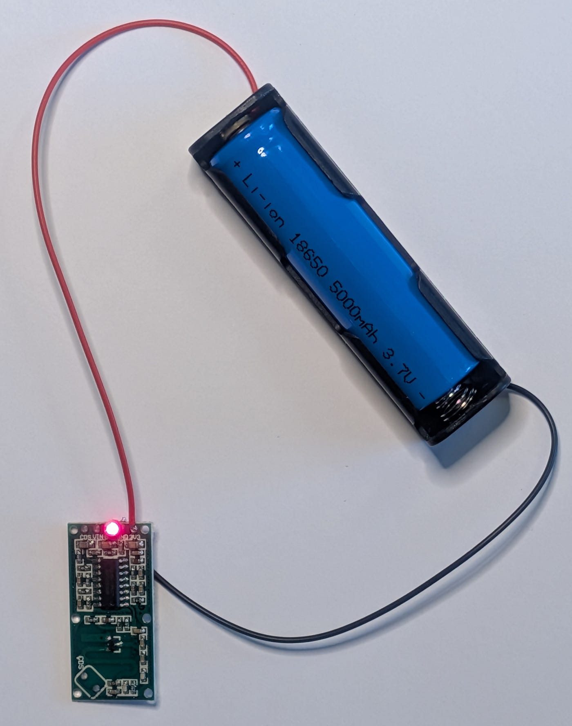

In the photo above, I have soldered a red LED between the output and ground, and powered the device from a 3.7-volt battery connected to the +3.3-volt input. The device can handle 4.2 volts on that input, but it also has a VIN input that connects to a voltage regulator, allowing as much as 28 volts to be used. It will run a long time on a 9-volt battery that way, as it consumes less than 3 milliamperes of current (more if the LED is lit).

The output stays on for about 5 seconds. You can increase this by adding a capacitor and/or a resistor on the back of the board. That’s the normal mode.

But we aren’t going to use the board in its normal mode. We’re going to hack it to do much more.

Let’s look at a schematic of the board:

Press enter or click to view image in full size

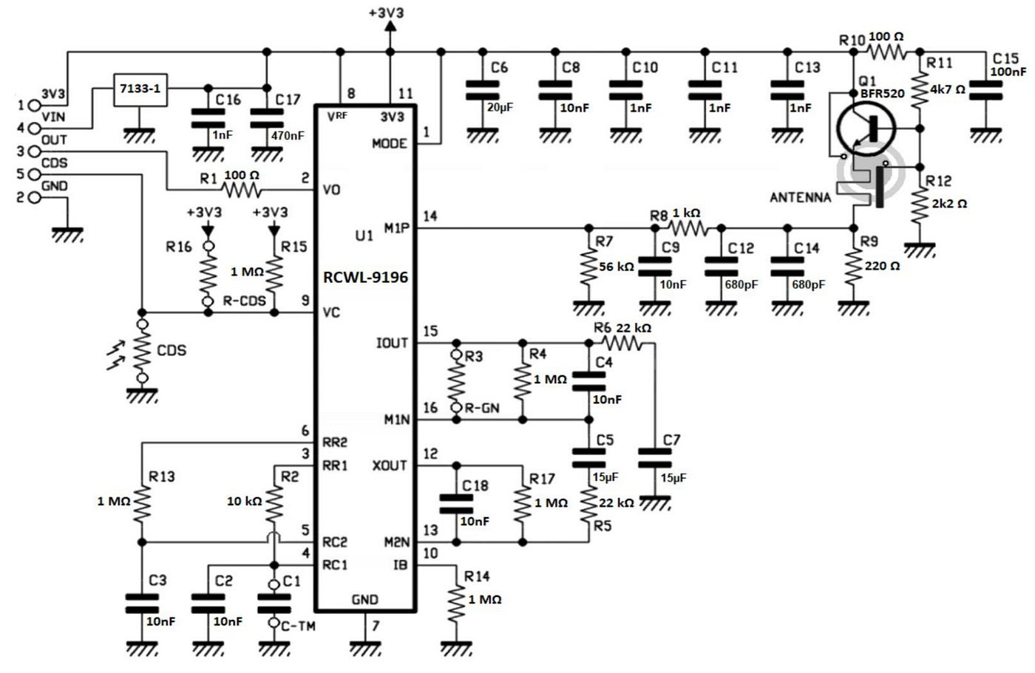

<https://www.mantech.co.za/datasheets/products/RCWL-0516.pdf>

The transmitter is the transistor at the right, forming an oscillator at about 3.175 GHz.

The antenna both sends out the signal and receives the echo. The echo signal is mixed in that same transistor, forming the sum and difference frequencies, just like a superheterodyne receiver. The sum frequency is filtered out on the way to pin 14 of the integrated circuit, leaving the low-frequency difference signal.

Below is the schematic of the integrated circuit:

Press enter or click to view image in full size

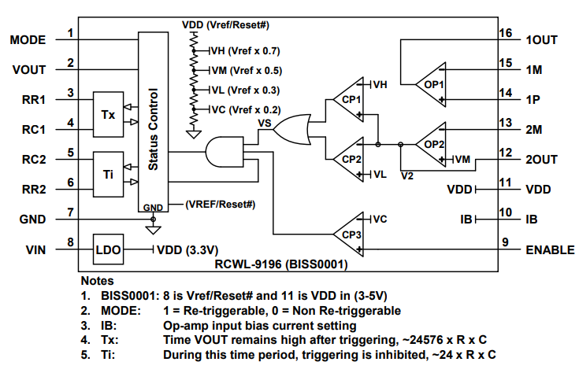

<https://www.snapeda.com/parts/rcwl-9196/RCWL/datasheet/>

We are going to ignore most of it. What we want is the operational amplifier labeled OP1. The weak difference signal from the antenna and mixer comes in on pin 14. We want the amplified version of that on pin 16.

While it is possible to solder a thin wire to pin 16 on the IC, that’s a little tricky because the pins are very small and close together.

But we’re in luck.

Resistor R3 on the schematic of the entire board is labeled R-GN. It does not exist on the board as it comes in the mail. It is there for the user to provide if she wants more control of the receiver gain.

Notice that one side of the resistor connects to pin 16.

Press enter or click to view image in full size

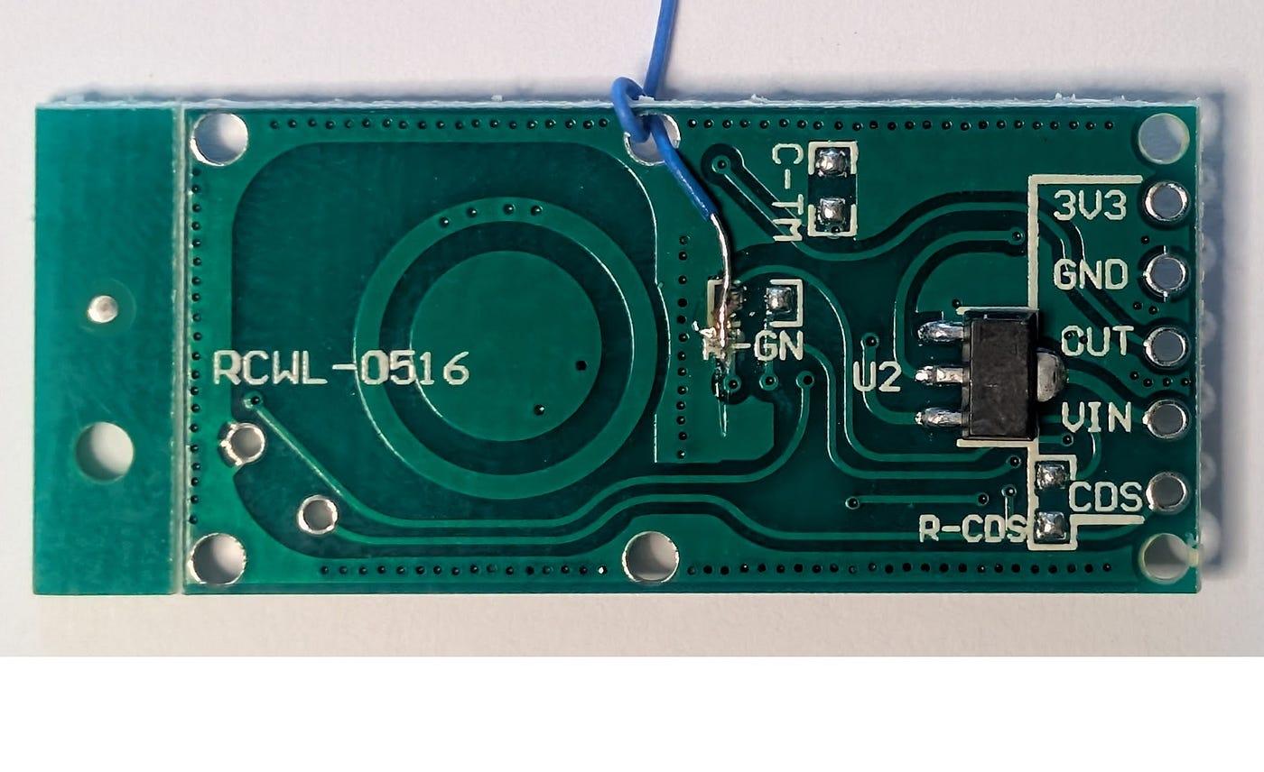

Here I have soldered a 30-gauge wire to the left solder point of where R3 would go.

Now we have the unprocessed signal from the receiver. We can feed it into an ESP32-C3 Super Mini’s analog-to-digital converter and look at the signals.

Let’s first look at it on the oscilloscope:

Press enter or click to view image in full size

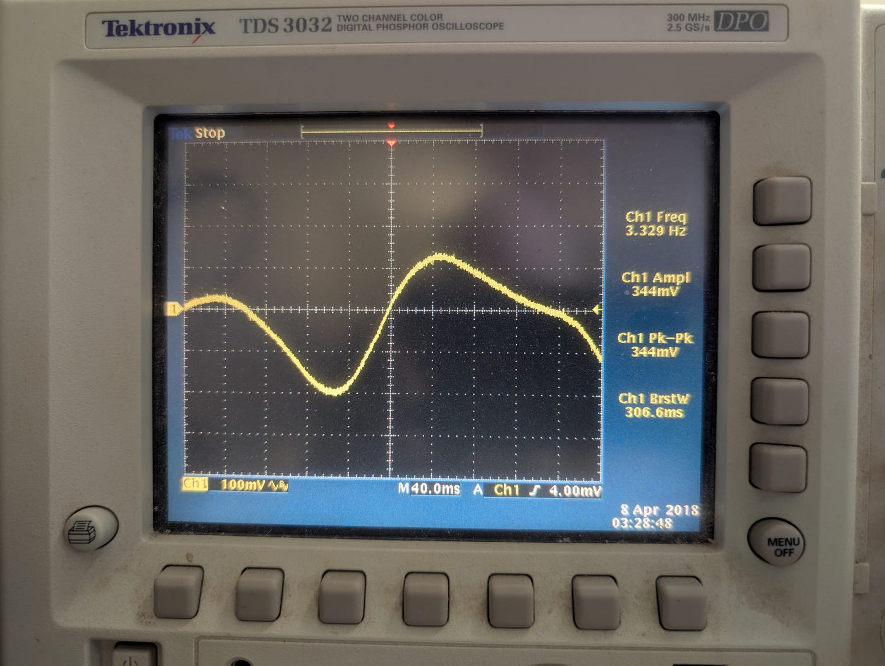

Here I was moving closer to the board, causing a 3.329 Hz signal on pin 16.

The peak-to-peak voltage was 0.344 volts, well within the range of our ADC.

Now we can connect it to the Super Mini:

Press enter or click to view image in full size

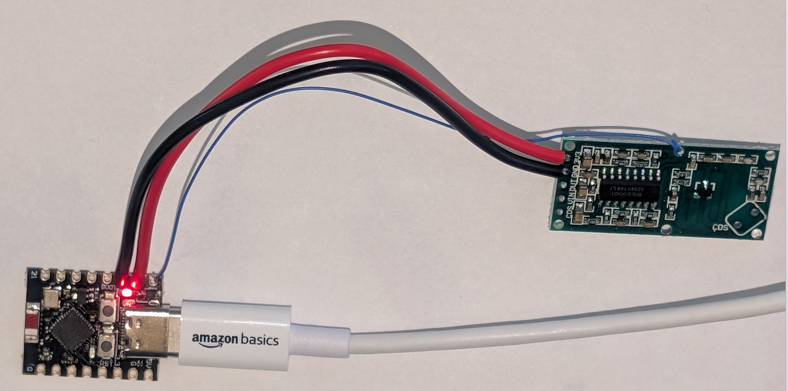

We use pins 5, 6, and 7 on the Super Mini.

Pin 5 will be the ADC input.

Pin 6 we will set to HIGH to power the board.

Pin 7 will act as the ground for the board.

Here is some Micropython code for the Super Mini:

def main():  
 from machine import Pin, PWM, ADC  
  
 data_pin = Pin(5, Pin.IN)  
 power = Pin(6, Pin.OUT, Pin.DRIVE_3)  
 ground = Pin(7, Pin.OUT, Pin.DRIVE_3)  
 led = Pin(8, Pin.OUT)  
  
 ground.off()  
 power.on()  
  
 data = ADC(data_pin)  
  
 while(True):  
 # print(data.read())  
 if data.read() > 3000:  
 led.off()  
 else:  
 led.on()  
  
main()

We have turned the device into a 3.16 GHz Morse Code receiver.

You may remember that I bought ten of these little boards. Some of that redundancy was my expectation of destroying one or two while soldering, but that didn’t happen. Another reason for wanting more than one is to use one as a Morse Code transmitter:

Press enter or click to view image in full size

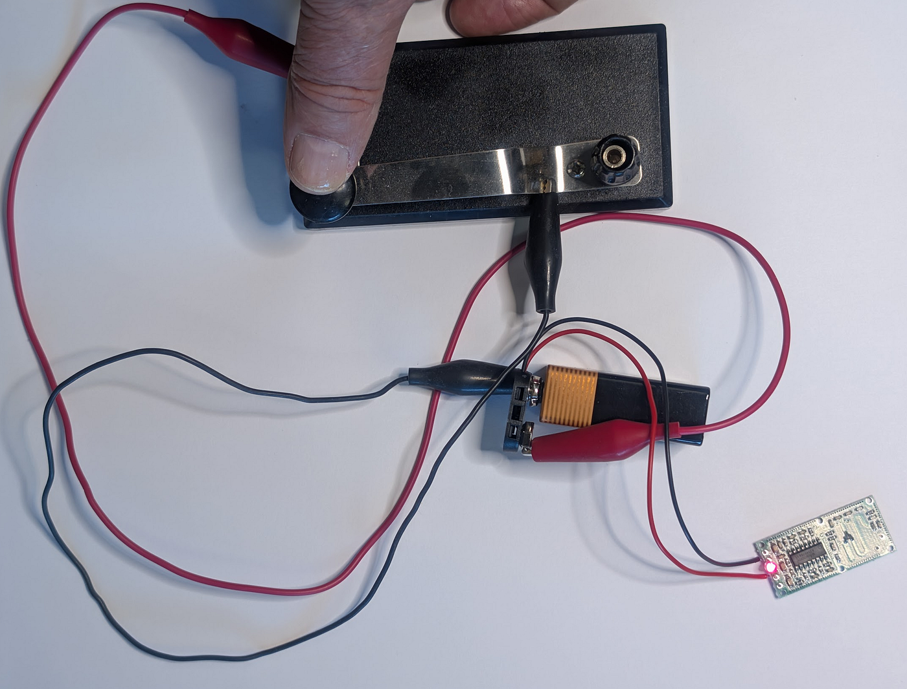

As you can see, I went all-out on the construction details. The code key acts as a switch, powering up the board from a 9-volt battery connected to VIN.

The red LED is the one I soldered to the board to use it as a motion detector. It still detects motion, but we ignore that.

Now, when I tap out Morse Code on the transmitter, I see the little blue LED on the Super Mini light up in sympathy.

Why did I use pins 6 and 7 to power the board instead of 3.3 volts and ground?

Because we can use the Super Mini to key the board. We can use the program we built in [Python Radio 27](https://medium.com/radio-hackers/python-radio-27-work-the-world-3f7ea682348c), and have it use Pin 6. We don’t even need the extra transistor we used in that project.

Our 3.16 GHz transmitter has a wavelength of 94 millimeters. About the length of a cigarette. It travels through wood easily, but gets blocked by glass and metal.

[Programming](https://medium.com/tag/programming?source=post_page-----49a4dccc82d7---------------------------------------)

[Python](https://medium.com/tag/python?source=post_page-----49a4dccc82d7---------------------------------------)

[Radar](https://medium.com/tag/radar?source=post_page-----49a4dccc82d7---------------------------------------)